Here we see that the OF update callback will always execute before the GLUT main loop, which will call the draw function, any input handlers, and other such events.

file: ext/openFrameworks/libs/openFrameworks/app/ofAppGlutWindow.cpp
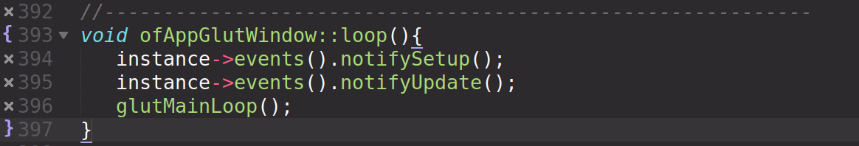
GLUT dispatches events through callback functions, such as the following:

file: ext/openFrameworks/libs/openFrameworks/app/ofAppGlutWindow.cpp
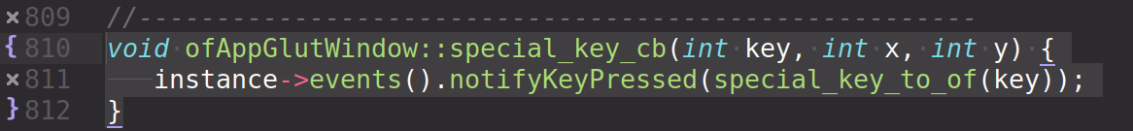
Notice that GLUT is just calling normal C/C++ functions in it’s event loop, not some special event object. It is this OF function that ends up dealing with the event objects.

https://github.com/dcnieho/FreeGLUT/blob/0d98472817921dc95d070f13bba59b72d792a7b2/freeglut/freeglut/src/fg_main.c
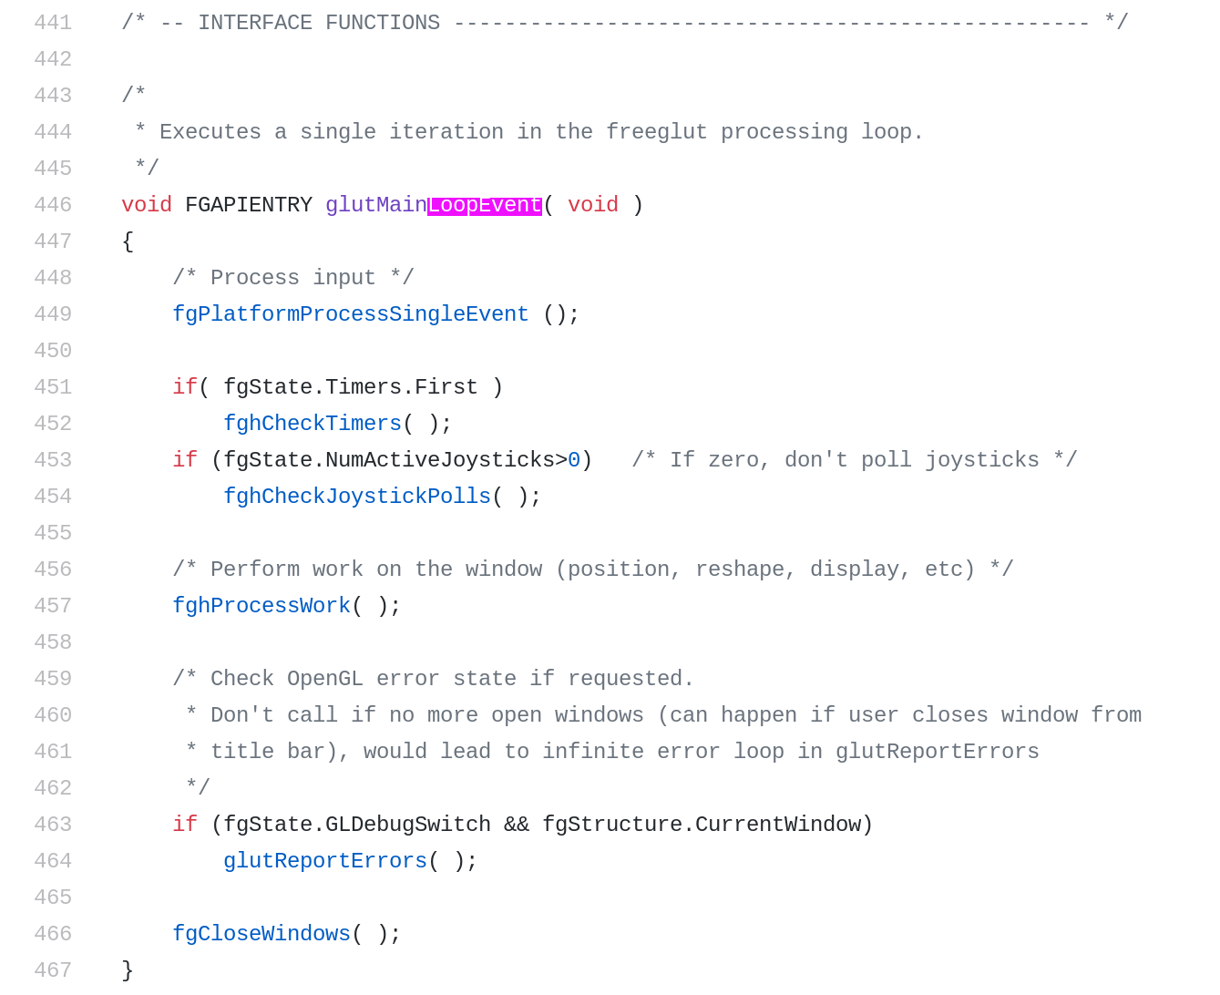
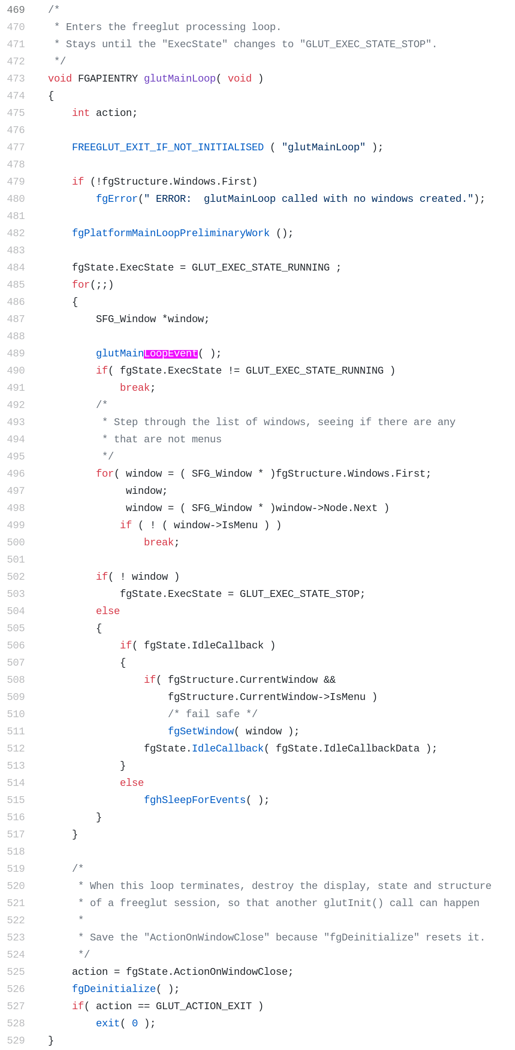
same file from GLUT

Here is the definition of the GLUT main loop, as seen in the freeglut implementation used on Linux.

Conclusion:
Event callbacks should fire in a deterministic manner.

The ordering of events is:

update
process input
draw

More info on GLUT events:

https://www.sjbaker.org/steve/software/glut_hack.html

